RE knowledge organiser: Year 3
Autumn term 2: How Do Christians Believe Following Jesus’ New Commandment and His 2 Greatest Commandments Make A Difference?
How Do Christians Believe Following Jesus’ New Commandment and His 2 Greatest Commandments Make A Difference?  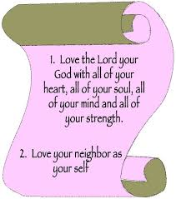  This term, we will be learning about what Jesus taught and told people to do, how Christians can relate Jesus’ teaching to their own questions of values and attitudes. | 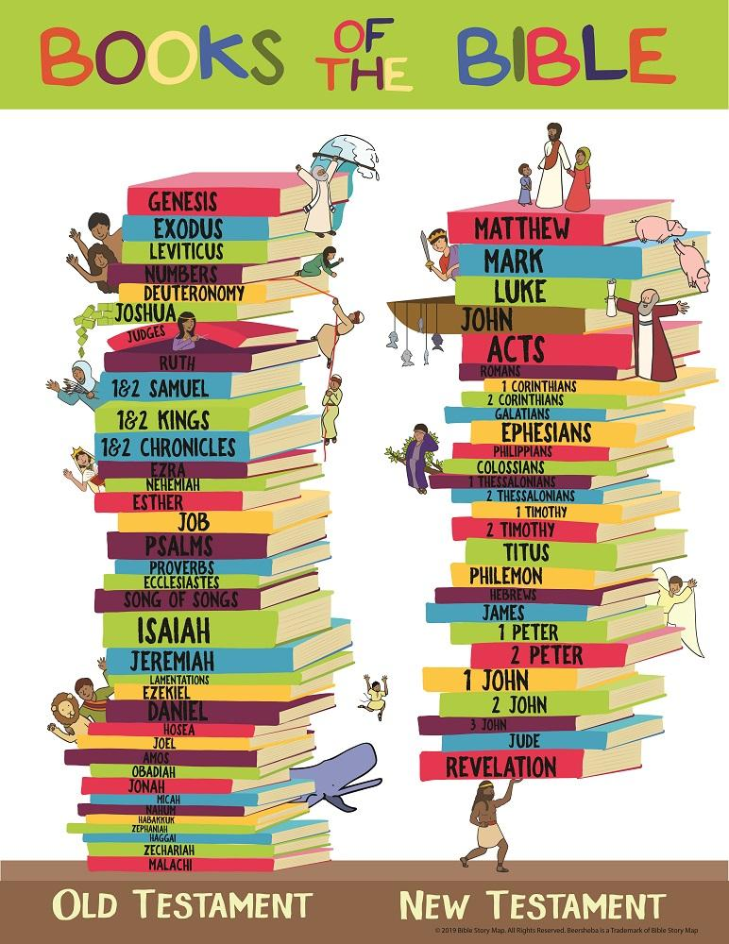 | Word Bank!  Love  Commandment  Jesus  Charity  British Values  Community  Values
Scriptures
John 13:34
The BIG Question!

What did Jesus teach and tell people to do?  Our little learning questions…  How can we relate Jesus’ teachings to our own questions of value and attitudes? | - Love the Lord your God with all your heart, with all you mind, with all your strength and with all your soul  I must remember…  There were two great commandments  2. Love one another as you love yourself.
At the end of the unit, I must …
- Know what the two greatest commandments for Christians are
- Be able to reflect on the values I have and how it effects the way I live
- Be able to talk about what rules I think people should live by and why

RE knowledge organiser: Year 3
Autumn term 2: How Do Advent and Epiphany Show Us What Christmas Is REALLY About?
The BIG Question!  How do Advent and Epiphany show us what Christmas is REALLY about?  We will be learning about Advent as a time of preparation we will be looking at the signs in the Bible that point to the birth of Jesus.  We will look at what the message of Christmas means for the people of God and the clues that can be found in the celebration of Epiphany about Jesus’ life. |  | Word Bank!  Advent (calendar, candle,wreath)  Bible  Old Testament  New Testament  Prophet  Message  Messenger  Foretell  John the Baptist  Prepare  Waiting  Expectation  Hope  Jesus  Incarnation  Giving  Charity  Christian  faith  Epiphany  Gift (gold, frankincense, myrrh)  king  wise men  magi  star
Scriptures
Matthew 11:9-10 and 3:1-3
Mark 1:3
John 1:27
Luke 16:16
Isaiah 7:14 and 9:6;
Micah 5:2
Psalm 72:11
Isaiah 53:3-7
Zachariah 9:9

L2: How Did John The Baptist Prepare The Way?

L1: What Did The Prophets Foretell About The First Christmas?  I’m learning about…  Prophets in the Old Testament already told the people of God that Jesus was coming!  L4: What Clues Does Epiphany Give Us About Jesus’ Life?  L3: How Is The Message of Christmas Lived Out  Among The People of God? | Epiphany is when something is revealed to you  I must remember…  Jesus was going to be the saviour of the world. God’s son sent to save people from their breaking of the God’s rules.  A new candle is lit on each of the four Sundays before Christmas
At the end of the unit, I must …
- Be able to talk about what the clues in the Old Testament about Jesus.
- Remember what the word Epiphany means
- Be able talk about what John the Baptist did to prepare people for coming of Jesus
- Remember the different names given to Jesus

